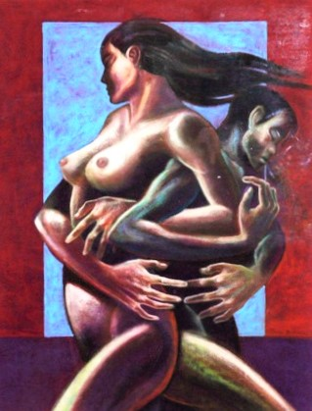

*Jeho Bitancor*

“Kapit Bisig”.

Mixed media on paper.

28” X 32”

“Kapit Bisig” is Tagalog for “Arms linked in unity”